**Covid Case Using DataBricks**

**Display the files in DataBricks using Scala:**

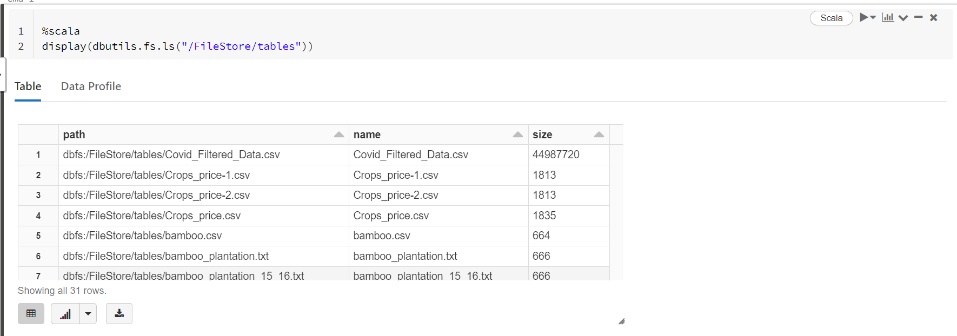

**Reading the file:**

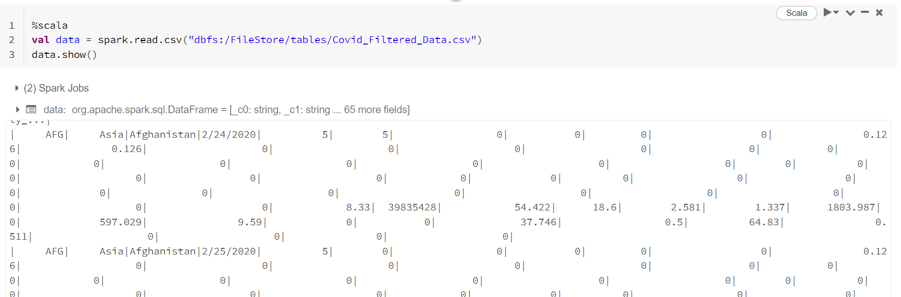

**Creating Temporary View:**

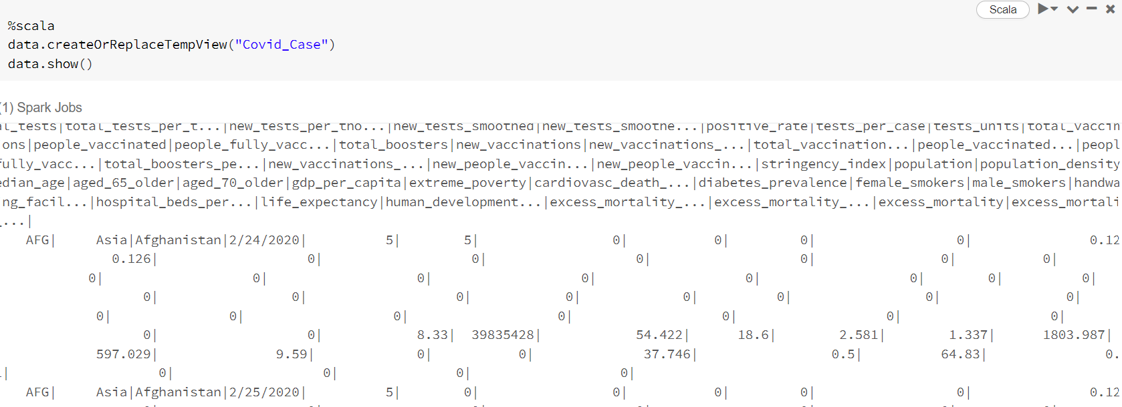

**6. Which location having lowest recovery rate for each continent.**

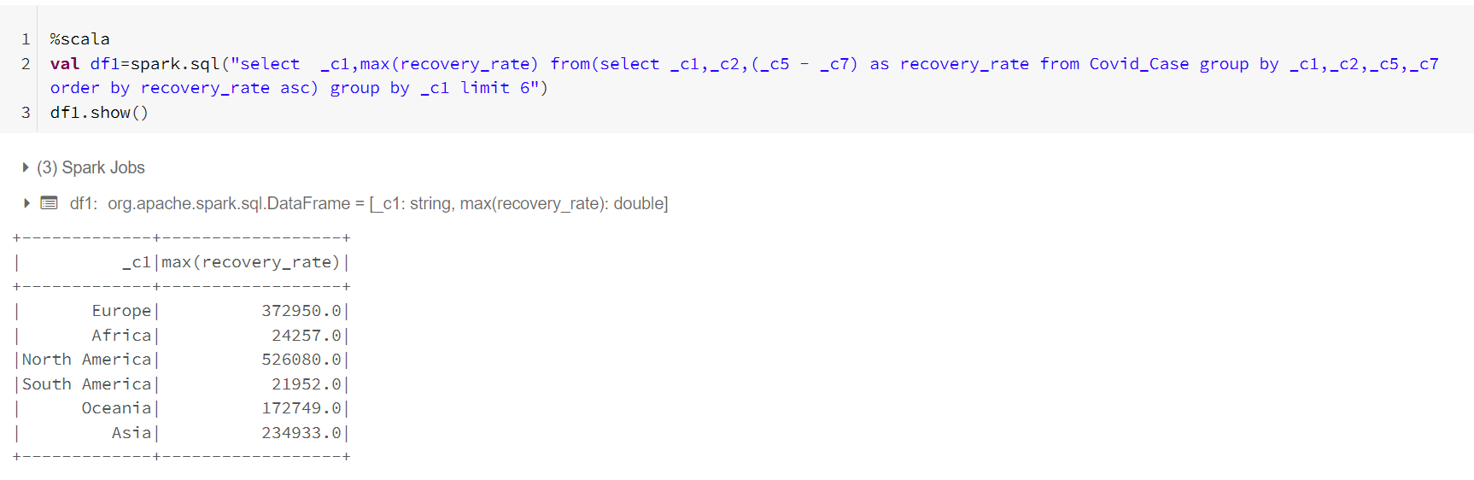

**7. Countries with max cardiovasc_death_rate and diabetes_prevalence greater than 10.**

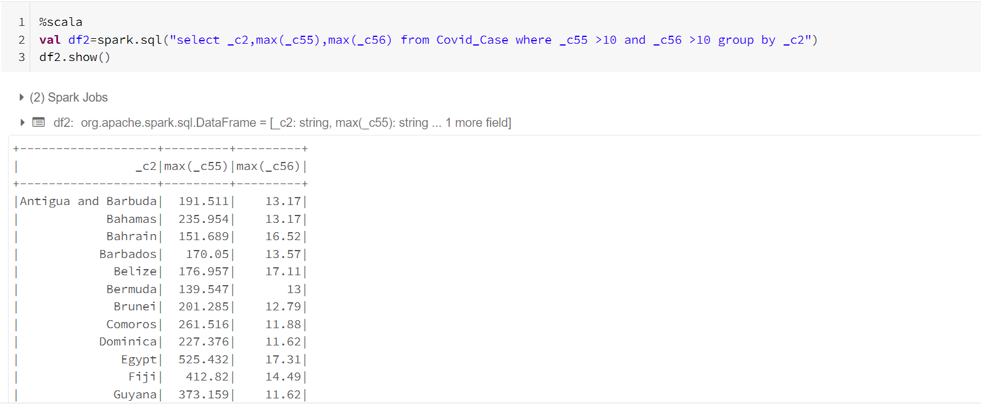

**8. Which location has highest number of vaccinated people in each continent.**

